**US Housing Market Analysis & Insights: 2008 – 2019**

**Key Findings**

1. **How have the average median house sales and foreclosure resale rates trended since 2008?**

Since 2011 and 2012, average median house sales have steadily increased (*see Exhibit 1*) and foreclosure resale rates have continued to decline (*see Exhibit 2*). The increase in average median house sales compounded with the decline of foreclosure resale rates indicates that the national housing market has been rebounding since the housing market collapse in 2008.

Exhibit 1: Seasonally Adjusted Median Sales Prices Over Time

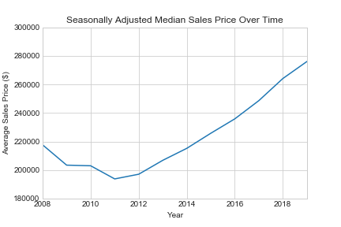

Exhibit 2: Percentage of Foreclosure Resales

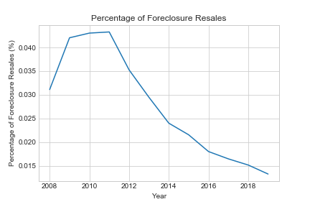

1. **What are the top five states with the highest increases and highest decrease in median house prices since 2008?**

For our analysis, we factored in all fifty states and the District of Columbia (DC). According to our results, the following five states experienced the highest increases in median sales prices since 2008: DC, California, Colorado, Washington, and Massachusetts. Interestingly, housing prices in these five areas began increasing in value consistently since 2011 and 2012 (*see Exhibit 3)*.

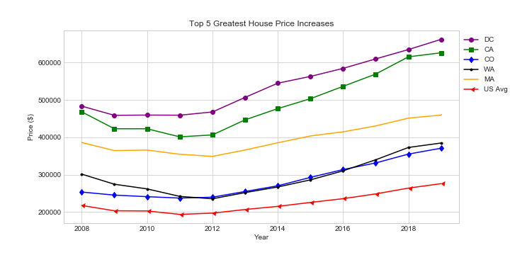Exhibit 3: Top 5 Greatest House Price Increases 2008 – 2019

According to our results, the following five states experienced the top five median sales price decreases for houses since 2008: Connecticut, New Jersey, Maryland, New Mexico, and West Virginia. States like Connecticut, New Jersey, and Maryland appeared to have been consistent with the national average around 2011 and 2012; however, New Mexico and West Virginia are different. Unlike the other states analyzed, New Mexico and West Virginia only started seeing an increase in housing prices since 2015 *(see Exhibit 4)*.

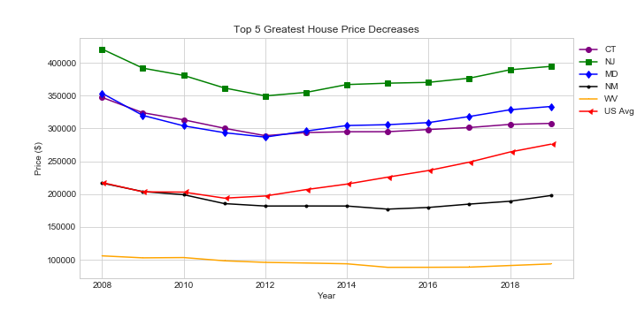Exhibit 4: Top 5 Greatest House Price Decreases 2008 - 2019

1. **What consumer/market variables affected median sales prices for homes since 2008?**

To see what may be affecting the median sales prices for houses, we developed a correlation matrix showing correlations of consumer/market variables against the average median sales prices for the top five states with the highest increase and highest decrease in housing prices. The variables we looked at for correlations with median sales prices included the following: Zillow Home Value Index, Monthly Home Sales, Foreclosure Resales, Divorce Rates, Unemployment Rates, Student Loan Debt, Total Debt, and Median Household Income. Each state’s median sales prices for houses appeared to have different correlations with the variables we analyzed, which illustrates no one state’s median sales prices for homes are affected by the same variables. The following shows the p-values for the top variables against median sales prices for homes in DC and Connecticut (*see Exhibit 5):*

Exhibit 5: DC and Connecticut Variable P-Values

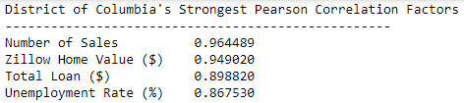

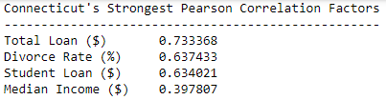

To further illustrate the correlations, the following plots show the top three variables correlated with the median sales prices for homes in DC *(see Exhibit 6)* and Connecticut *(see Exhibit 7)*:

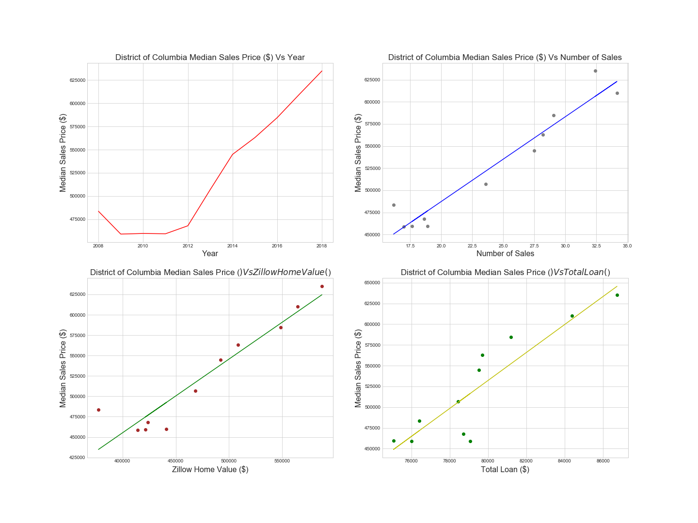Exhibit 6: DC Median Sales Price Variable Plots

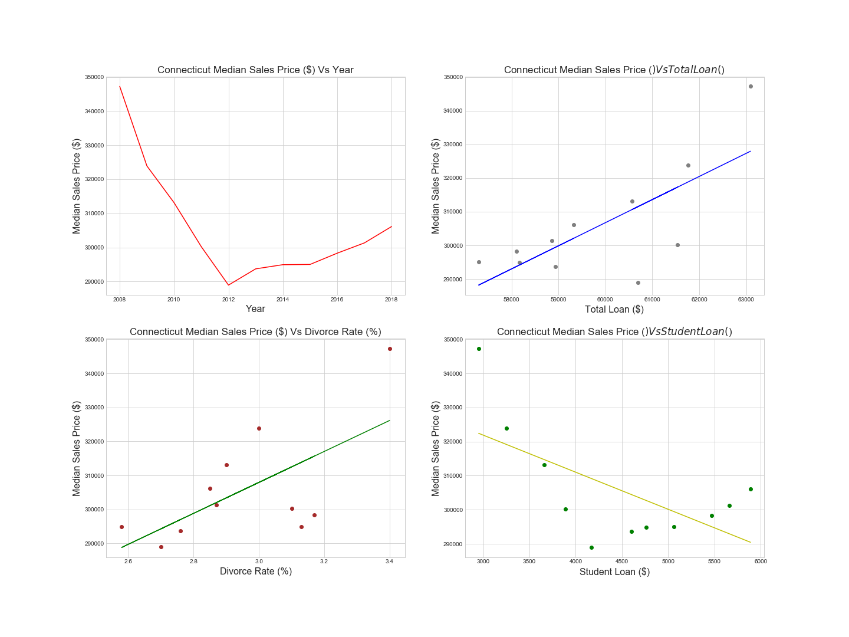Exhibit 7: Connecticut Median Sales Price Variable Plots

1. **Based on the results of Question 3, what may future median sales prices look like?**

Our multiple regression model allowed us to input the year we wanted to analyze as well as inputs for the two most strongly correlated variables of a specific state. We tested our model on DC and Connecticut for 2020 (*see Exhibit 8)*. It is worth noting that the variables that most contributed to the predicted median sales price for DC and Connecticut varied: for DC the number of sales and Zillow Home Value were used to predict the price whereas total loan and the divorce rate were used to predict price in Connecticut. As a result, predicting future median sales prices will vary depending on state, the variables strongly correlated with median sales prices, and what inputs are used to forecast potential sales prices.

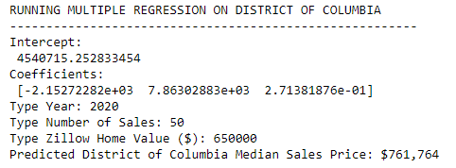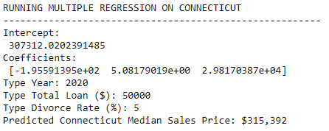Exhibit 8: Predicted 2020 Median Sales Prices for DC and Connecticut